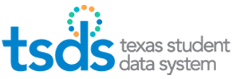

TSDS Load Summary Reports

TEA has provided a report (screen) at both the LEA level and the ESC level to view the Domains and Entities that have been loaded. The screen shows the Domains, Entities, and number of Records.

- Log into TEAL.
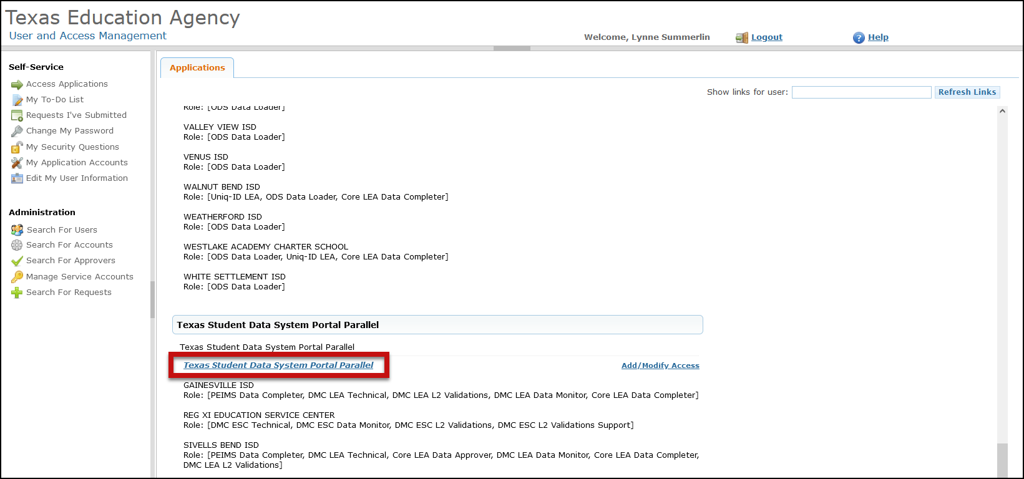
- Click on Texas Student Data System Portal Parallel link.

- Click on Manage IODS.
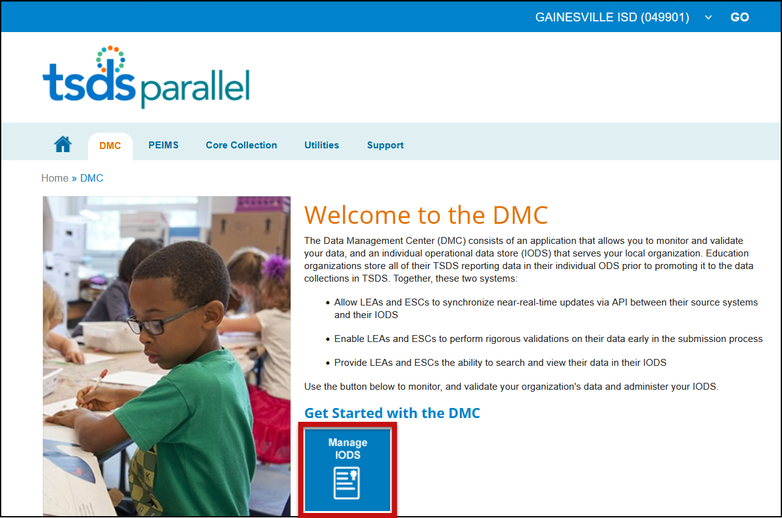

- On the Data Management Center (DMC) screen select View Reports > Load Summary.

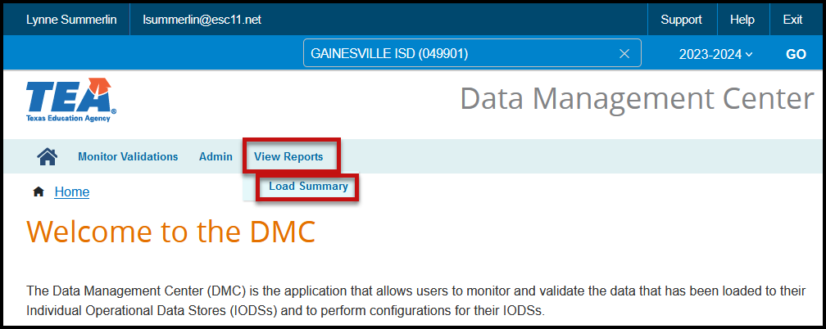

- The Load Summary screen appears with the Number of Domains Loaded for 2023-2024 and a list of those domains.

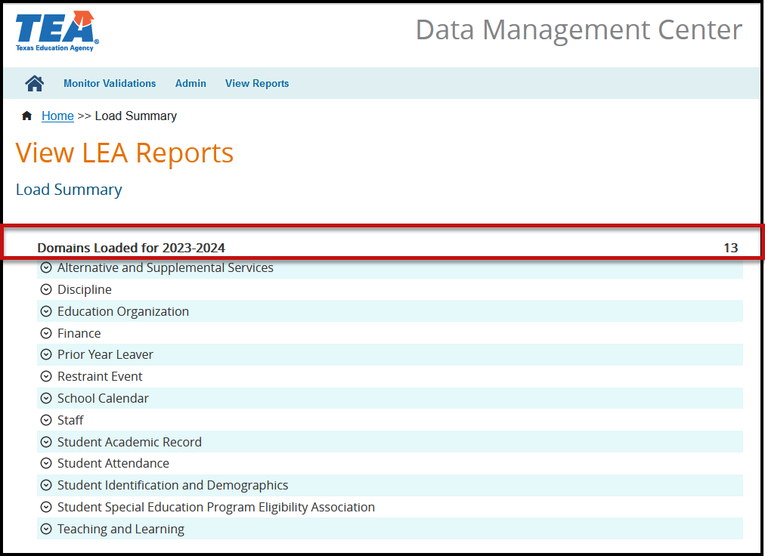

- Each Domain listed can be expanded to show a list of the Entities loaded and the number of records loaded for each Entity.

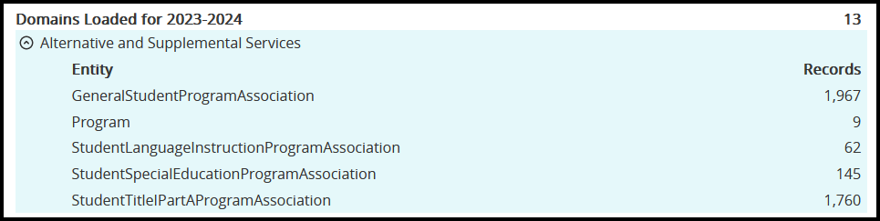
- These numbers should be compared to your SIS to verify that all data is extracting correctly. Below is a list of the Domains that are utilized in the TSDS Upgrade Project.

